

|  |  |
| --- | --- |
|  | The Raspberry Pi is   * a low cost, * **credit-card sized, single board computer** * that plugs into a computer monitor or TV, * [and uses a standard keyboard and m++ouse.](Raspberry%20Pi%20setup.jpeg) * It is a capable little device that enables people of all ages to   + explore computing,   + learn how to program in languages like     - Scratch and Python. * It’s capable of doing everything you’d expect a desktop computer to do,   + browsing the internet   + playing high-definition video,   + making spreadsheets, word-processing, and   + playing games. * has the ability to interact with the outside world   + This is what we are doing in this course * has been used in a wide array of digital maker projects,   + from music machines and   + parent detectors to   + weather stations and   + tweeting birdhouses with infra-red cameras. * Aim of the creator of the Raspberry Pi   + We want to see the Raspberry Pi being used by kids all over the world to     - learn to program and     - understand how computers work. |

**RASPBERRY PI 4**

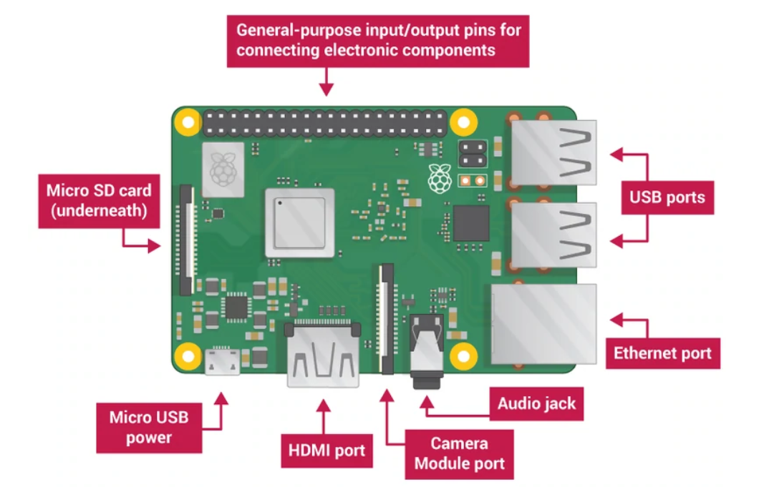

**The GPIO Pins on the Raspberry Pi allows us to connect it to the real world.**

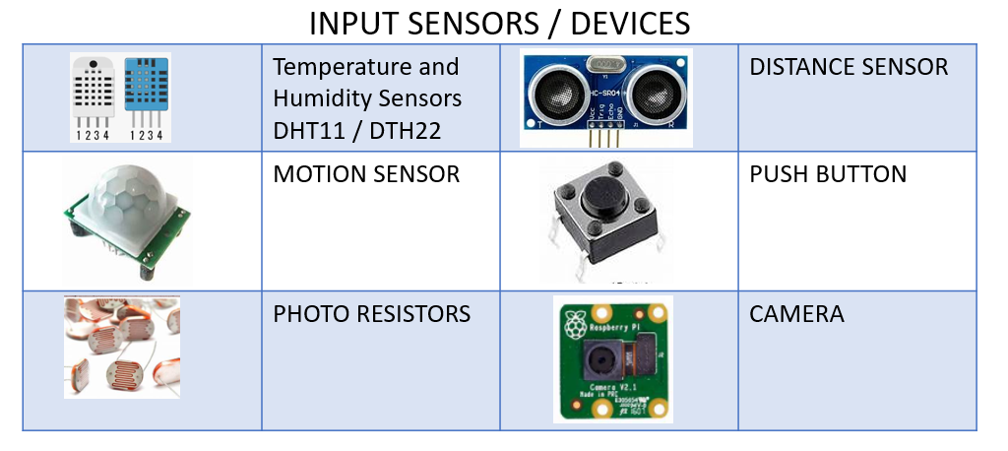

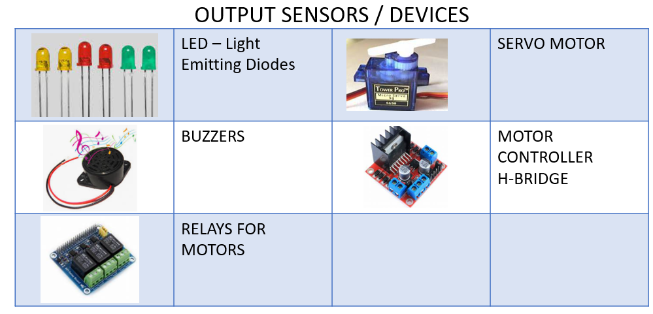

**Real World Applications using the Raspberry Pi**

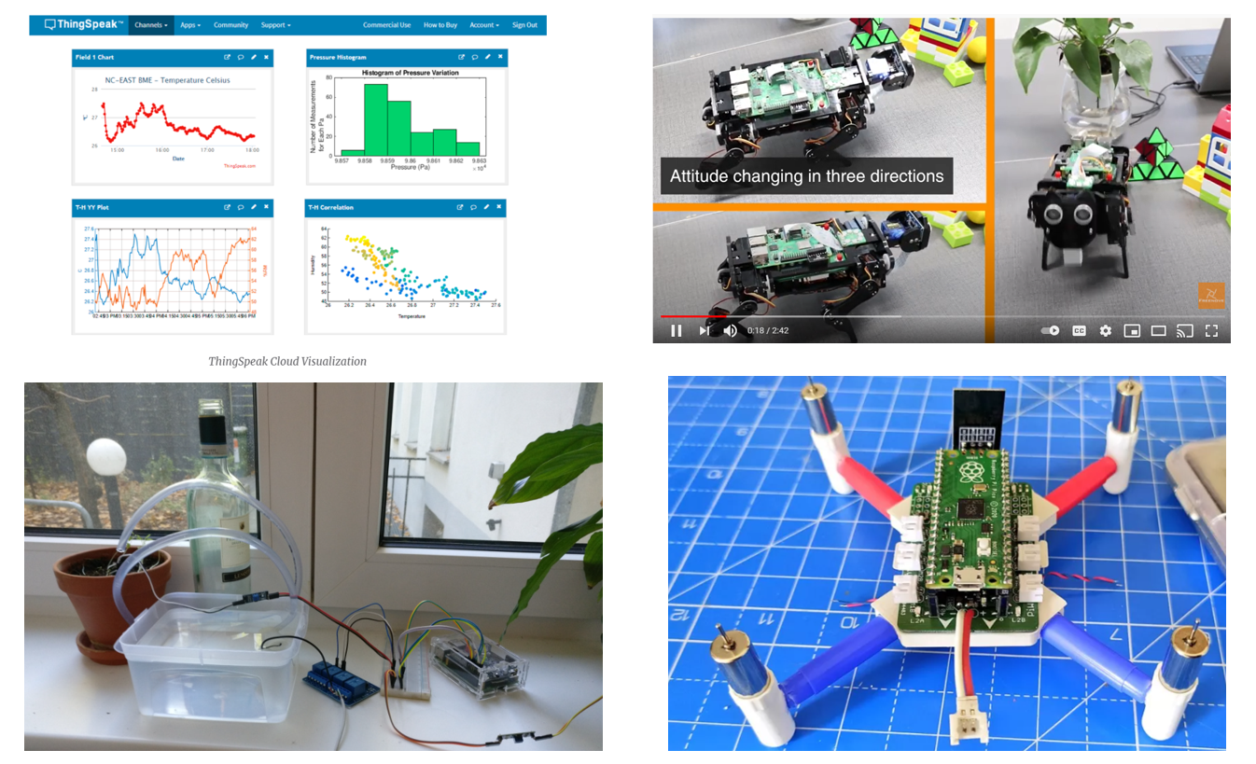

**Raspberry Pi 4 – PIN DIAGRAM**

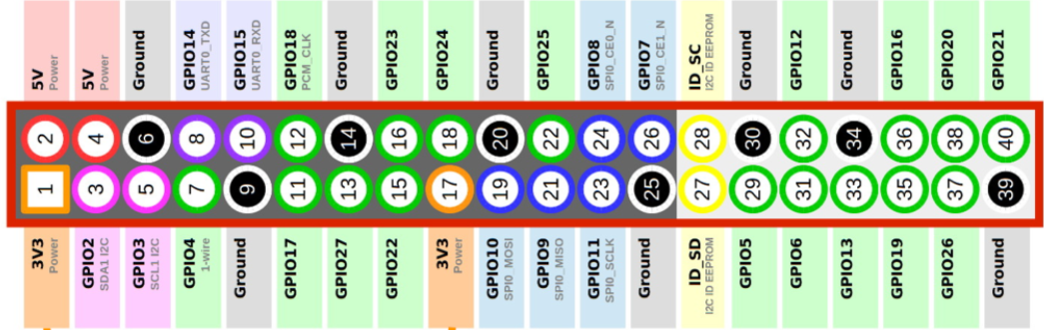

1

2

3

4

5

6

7

8

9

10

11

12

13

14

15

16

17

18

19

20

11

10

9

8

7

6

5

4

3

2

1

12

13

14

15

16

17

18

19

20

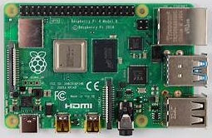**Raspb**

**GPIO14 / PIN 14**

**GPIO5 / PIN 6**

